MONICA GELLER

PART 1 - PERSONA

Target User Persona

30 JULY, 2020

User Persona: BUSINESS ORIENTED WOMENS

**Gender:** Female

**Age:** 31

**Education:** College Educated – UC Davis Grad

**Income:** Extra disposable income, looking to make business opportunity in creativity.

**Interest Affinities:** Having craft products, making new models from papers and selling them online, teaching kids to follow art.

**Primary Discovery Methods**: Facebook, Pinterest, Reviews from bloggers, Google

**Primary area of residence**: Urban areas (Mumbai, Pune, Aurangabad, Nagpur, Nashik)

**Jargon/Slang, etc used**: None

**Primary Concerns**:

Wants to buy craft product online so as to make good sales with handmade products. Desire to make a brand name or business by making creative arts. Wants to rely on some trusted websites so that it convenient to make purchase.

**Other Info:** Likely married, have kids, maybe an art teacher, open-mided.

Visits websites like: Amazon, Etsy, Shopify, etc.

Monica is concerned about the products she needs to make new craft. When searching for these products, she often uses terms like “craft” or “new art ideas.” Naturally she prefer products that are eco-friendly. As a new business-newbie she spends time reading blogs about sales, craft ideas and other tops she might need to know. Due to this, if a blogger she respects recommends a product, she is likely to check it out. Monica is also likely to ask her friends and family for recommendations on Facebook. She may be more susceptible to Facebook ads as well as Pinterest promotions. She frequently enters contests, and would respond well to contests featuring a give-away as well as share this with friends and family.

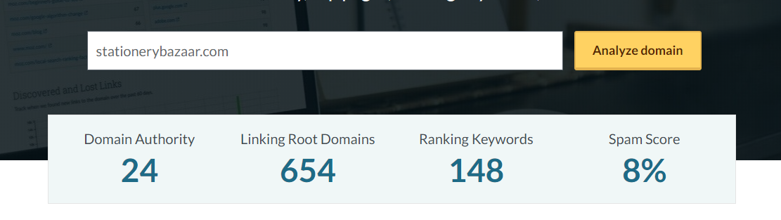

PART 2 - KEYWORD

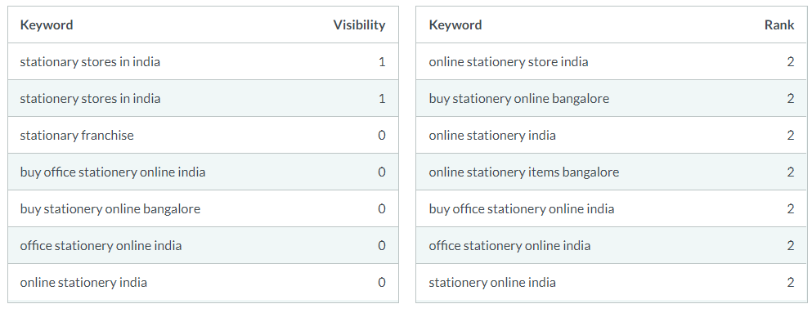

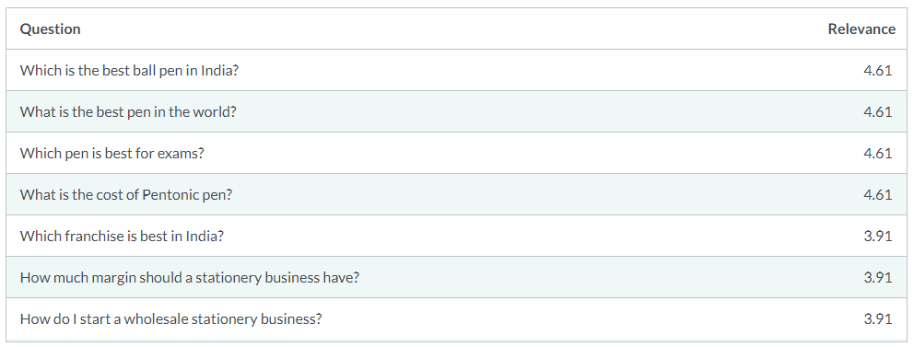

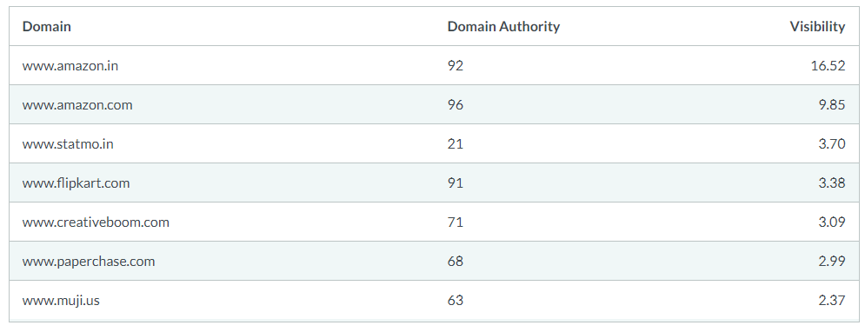

PART 3 - COMPETITIVEANALYSIS